Bash 02 Task:
Starting steps: Created instance and login to remote machine
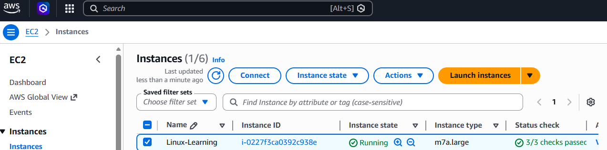
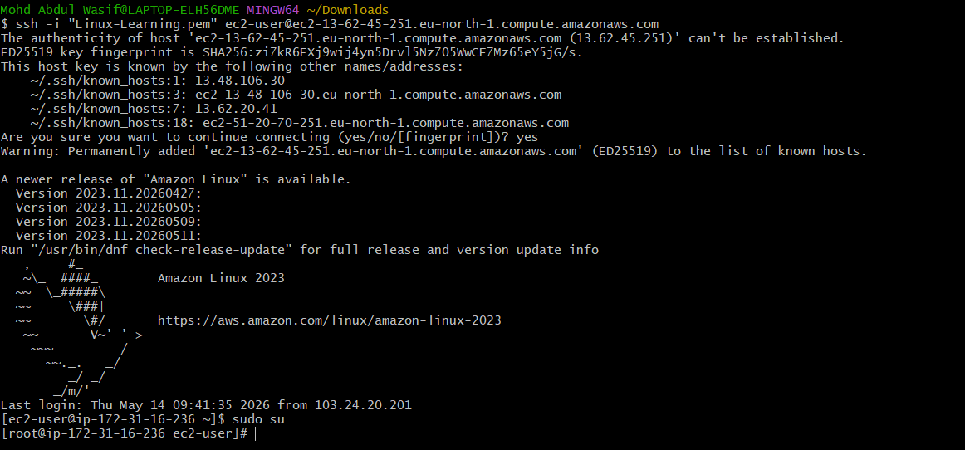
1: Conditions/if else statements: If then statement If this happens = do this otherwise = do that
Ex 1:

#!/bin/bash
count=100
if [ $count -eq 100 ]
then
echo count is 100
else
echo count is not 100
fi
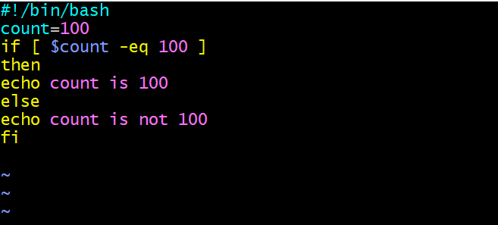
Out put:
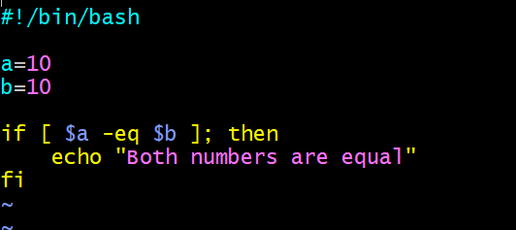
Output:
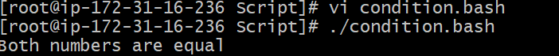

Ex2:
check if file is available
#!/bin/bash
if [ -e /home/error.txt]
then
echo "File exist"
else
echo "File does not exist"
fi
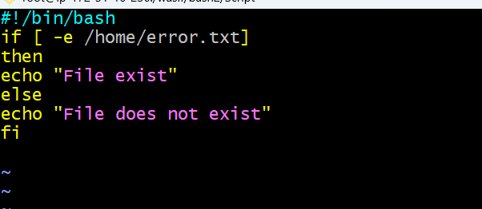
Output: Got error
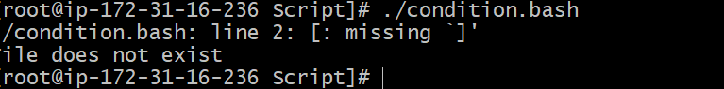
To fix it the error I went re correct the location actually I was tried for different location where the file doesn’t exist.
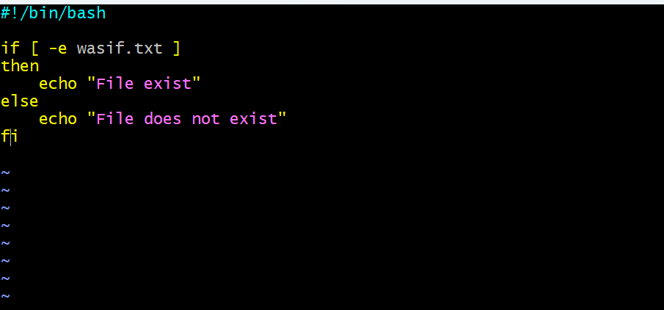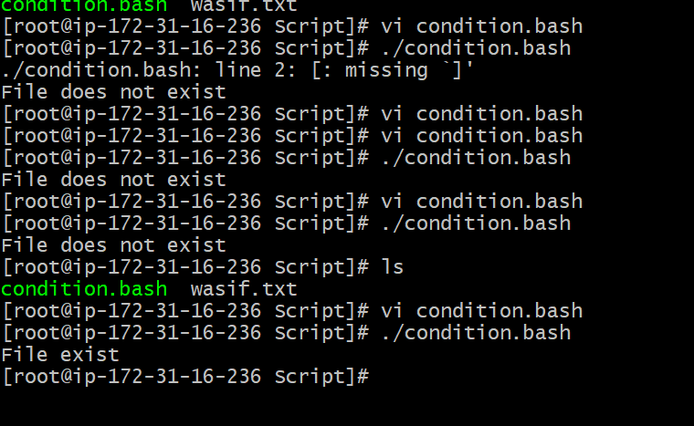

2: Case Statement Scripts: This will be used when we have multiple options to script
Case
if option a is selected = do this
if option b is selected = do this
Ex:
#!/bin/bash
echo
echo Please chose one of the options below
echo
echo 'a = Display Date and Time'
echo 'b = List file and directories'
echo 'c = List users logged in'
echo 'd = Check System uptime'
echo
read choices
case $choices in
a) date;;
b) ls;;
c) who;;
d) uptime;;
*) echo Invalid choice - Bye.
Esac
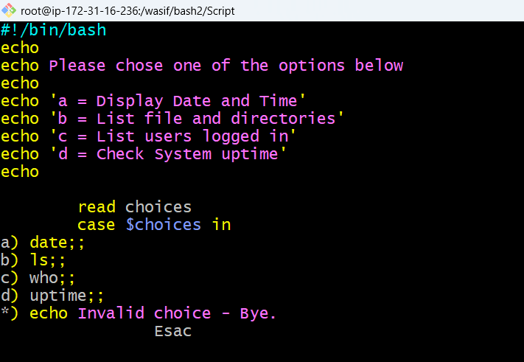
output:
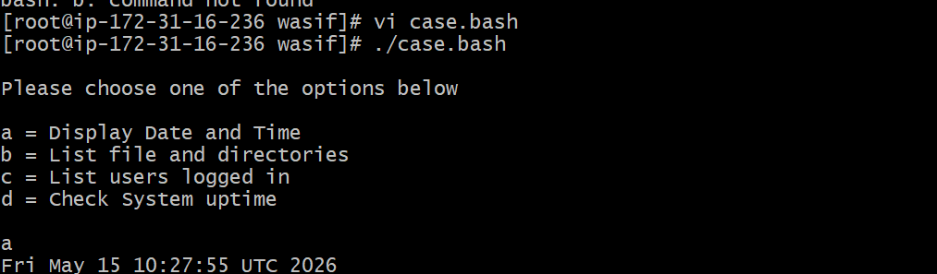

3: For Loop Scripts: For loop keeps running until specified number of variables.
e.g: variable = 10 then script run for 10 times.
or
variable = green,blue,red (then run the script 3 times for each color)
Ex:1
#!/bin/bash
for i in 1 2 3 4 5
do
echo "Welcome $i times"
done
Ex 02: #!/bin/bash
for i in {1..103}
do
echo "Welcome $i times"
done
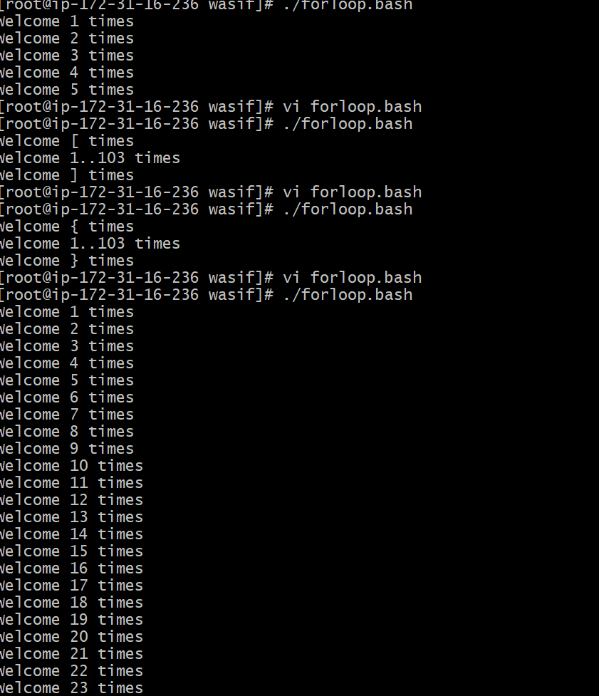

Ex:2
for i in eat run jump play
do
echo See Imran $i
done 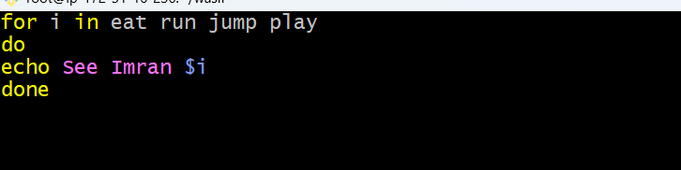
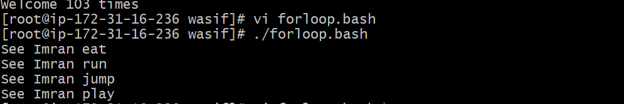
4: Do-while Scripts: This will continually execute a block of statements while a particular condition is true or met.
e.g: Run a script until 2 pm
while [ condition ]
do
command 1
command 2
commandN
done
Ex1:
#!/bin/bash
count=0
num=10
while [ $count -lt 10 ]
do
echo
echo $num seconds left to stop this process $1
echo
sleep 1
num=`expr $num - 1`
count=`expr $count + 1`
done
echo
echo $1 process is stopped!!!
Echo
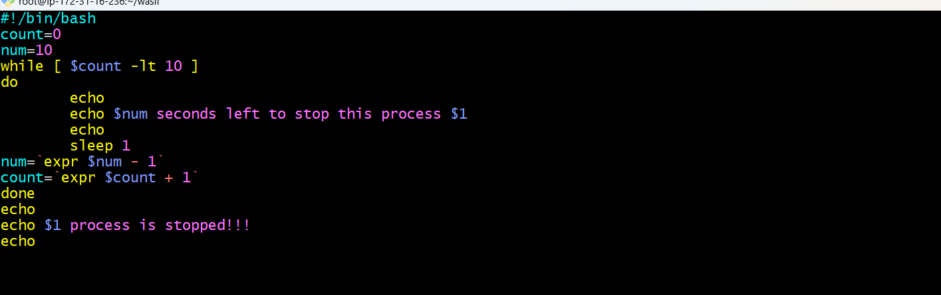
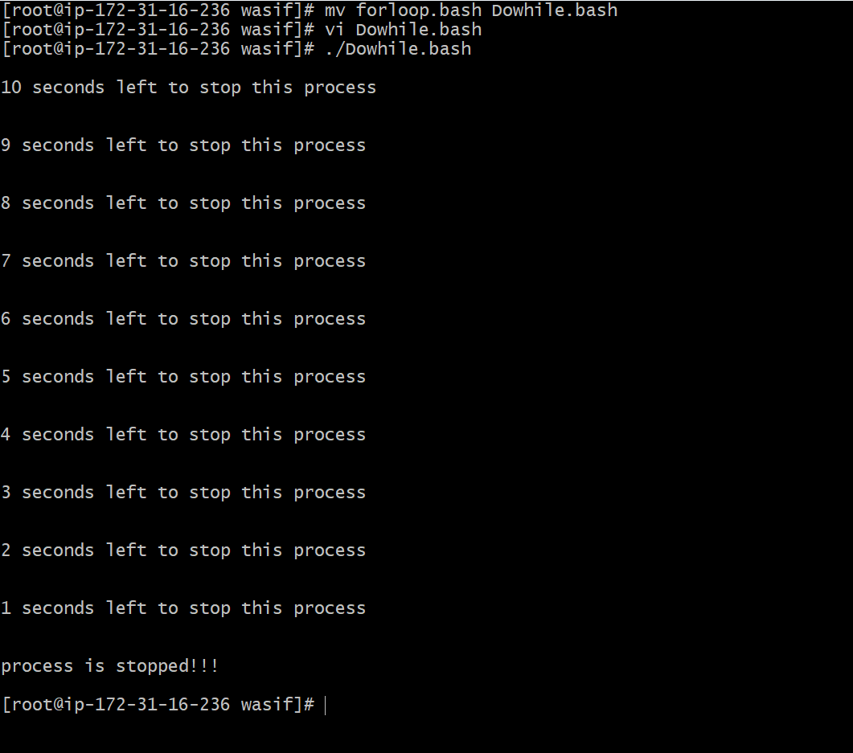
5: Exit status: Every time a command is execute in Linux it will have status is associated with it.
*) 0 = ok or successful
*) 1 = Minor problem
*) 2 = serious problem
*) 3-255 = Everything else
Why do we need exit status?
We actually do lot of comparisions in scripting and if the command is successful then do that or else do that.
How to check the exit status of previous execute command?
exit $?
Ex1:
#!/bin/bash
echo hello
echo $?
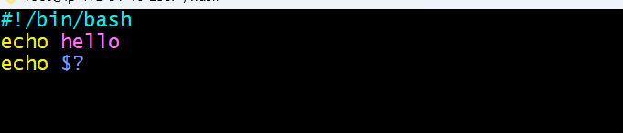
Ex2:
Return Un-Successful Exist Status
#!/bin/bash
echi hello
echo $?
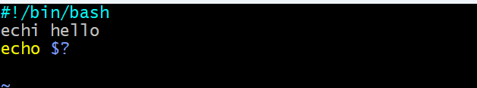
out put:
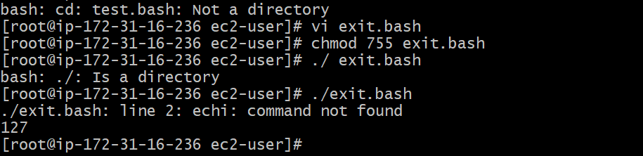
Ex3:
Return exist status if file exist
#!/bin/bash
ls -l /home/sabair/check
if [ $? -eq 0 ]
then
echo File exist
else
echo File does not exist
fi
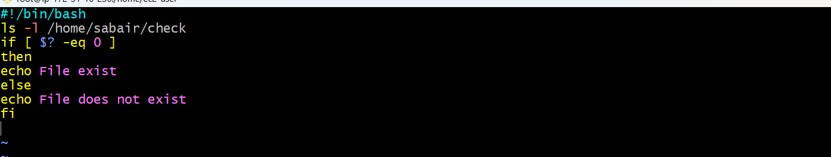
Output
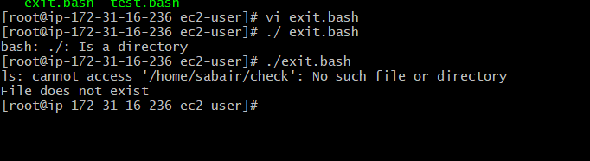
6 : Cronjobs: Cronjobs is used to run script without any manual intervention.
* * * * * command
│ │ │ │ │
│ │ │ │ └── Day of week (0-7)
│ │ │ │
│ │ │ └──── Month (1-12)
│ │ │
│ │ └────── Day of month (1-31)
│ │
│ └──────── Hour (0-23)
│
└────────── Minute (0-59)
Now install corn for system

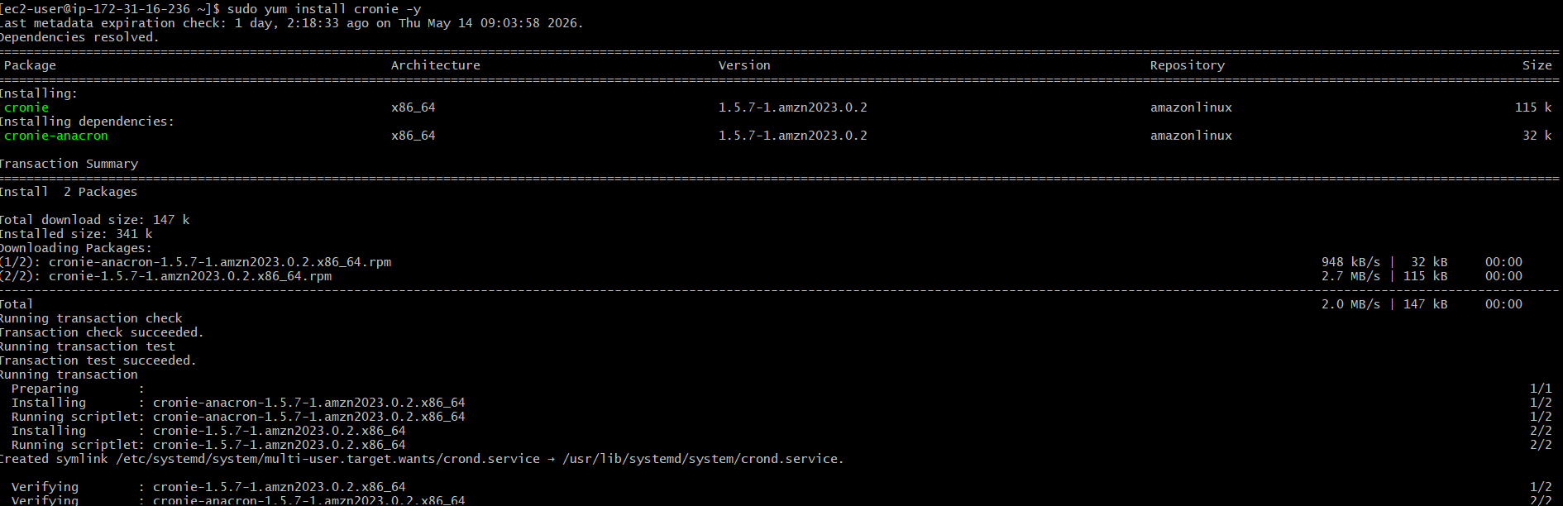
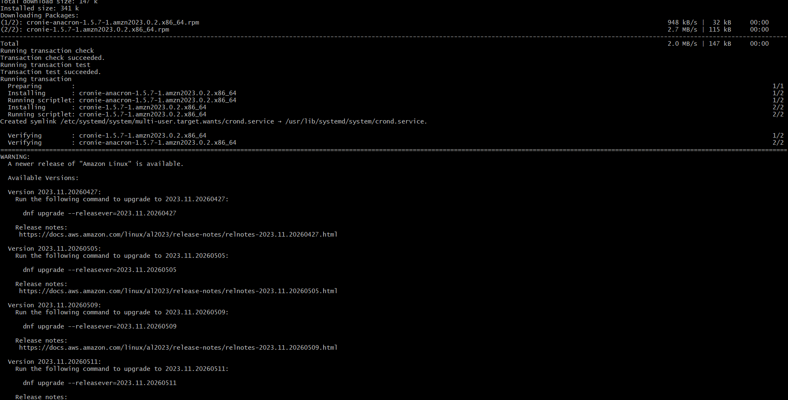
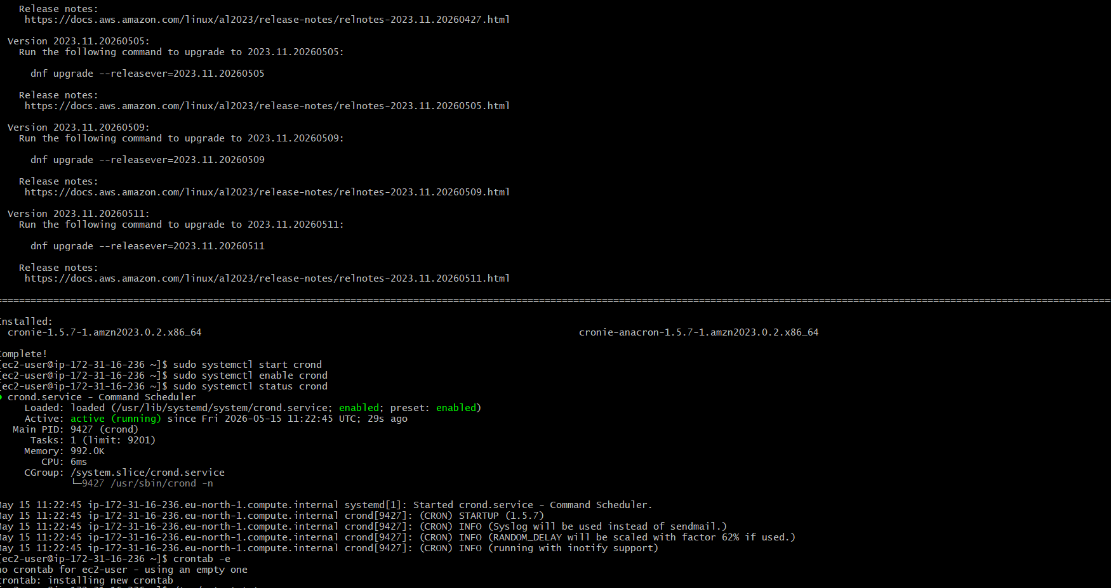
Check file exists
ls -l test.bash

2. If file is owned by root, change ownership
sudo chown ec2-user:ec2-user /home/ec2-user/test.bash

3. Give execute permission
chmod +x /home/ec2-user/test.bash

4. Check file permission
ls -l test.bash
Expected output:
-rwxr-xr-x 1 ec2-user ec2-user test.bash

5. Create / edit script (if needed)
nano test.bash
Script content:
#!/bin/bash
echo "Cron working $(date)" >> /tmp/output.txt

6. Test script manually
./test.bash
Check output:
cat /tmp/output.txt

7. Open crontab editor
crontab -e

8. Add cron job (runs every minute)
* * * * * /home/ec2-user/test.bash

9. Save and exit crontab
- Press ESC
- Type :wq
- Press Enter

10. Verify cron jobs
crontab -l

11. Check cron output file
cat /tmp/output.txt

12. (Optional) Check cron service status
systemctl status crond
13 Then continuous monitoring by tail -f /var/log/cron
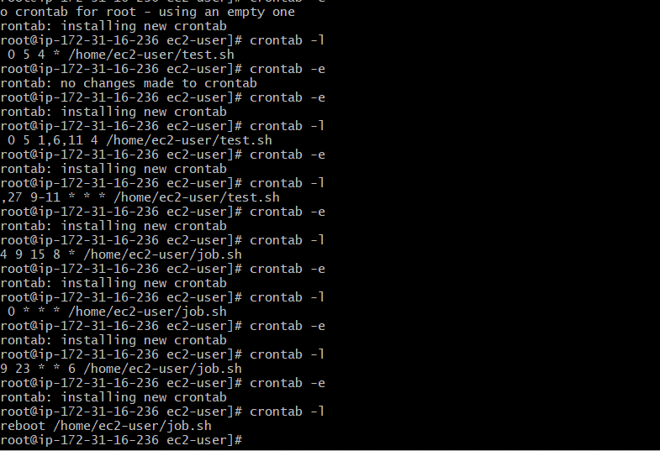

Note :- After above installation now worked on all the corn task..

Bash Script Tasks
- Create a bash script to check if a directory is available or not.
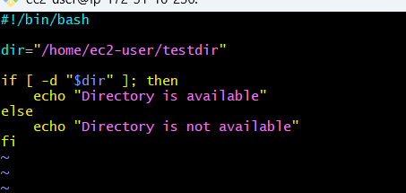
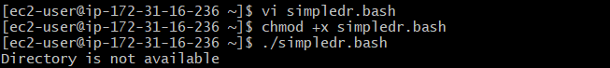
I scripted if directory not their then create new directory
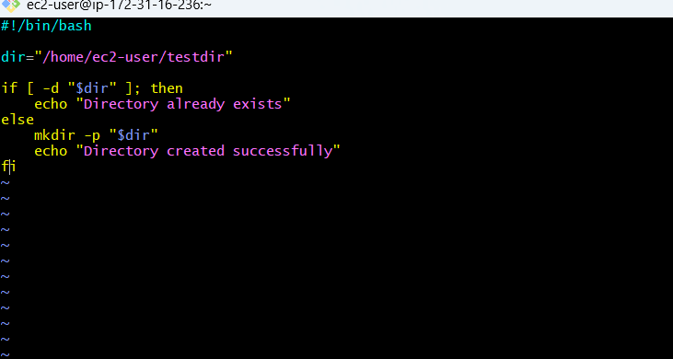
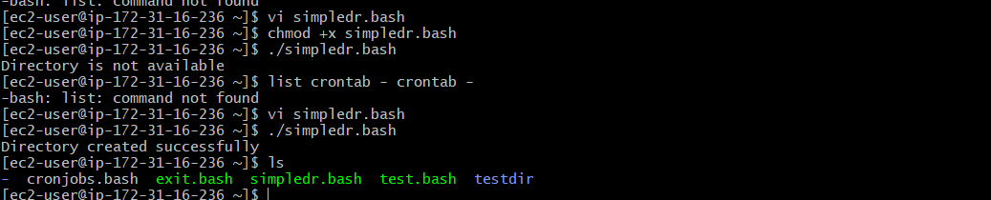
- Create a bash script to create multiple files.
#!/bin/bash
echo "Enter number of files:"
read n

for i in $(seq 1 $n)
do
touch "file$i.txt"
echo "Created file$i.txt"
done
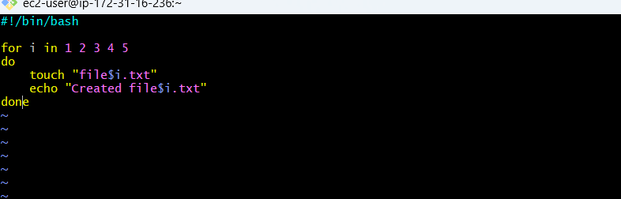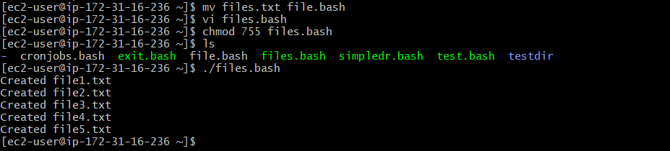

- Create a bash script to take a
backup of a directory.
#!/bin/bash
src="/home/ec2-user/testdir"
dest="/home/ec2-user/backup"
mkdir -p "$dest"
cp -r "$src" "$dest"
echo "Backup completed successfully"
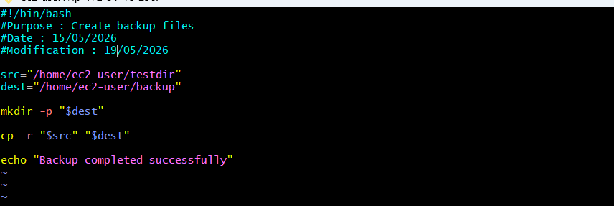
- Create a bash script to install Nginx on an EC2 server.
#!/bin/bash

sudo yum update -y

sudo yum install nginx -y

sudo systemctl start nginx

sudo systemctl enable nginx

sudo systemctl status nginx
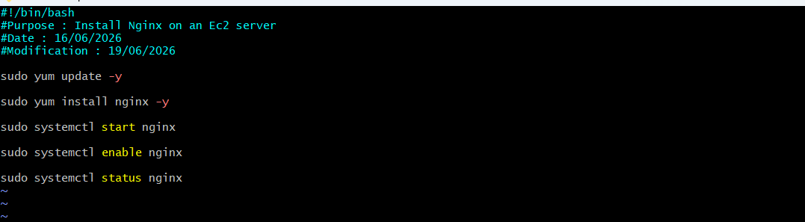
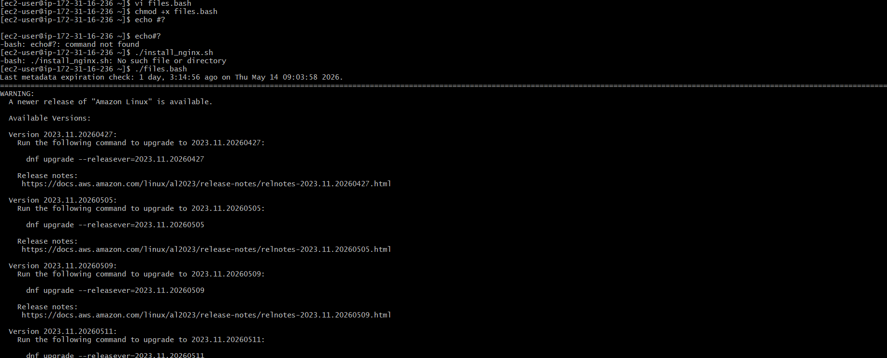
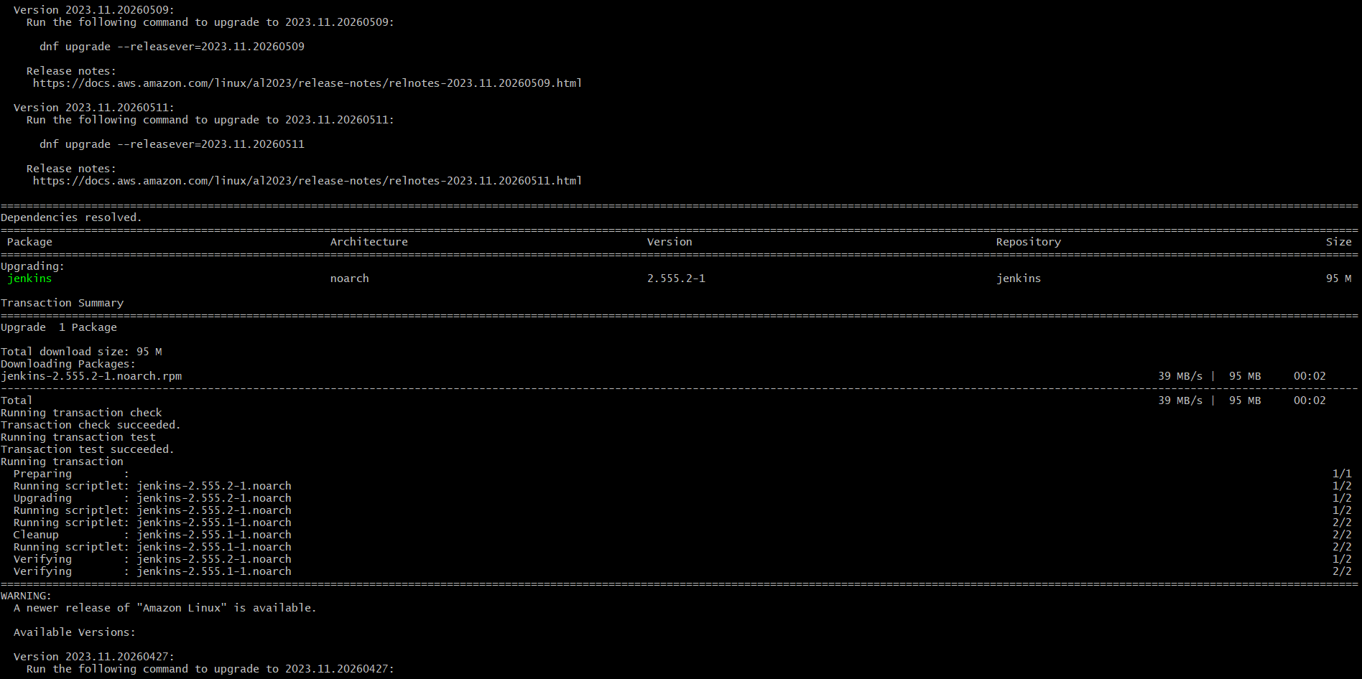
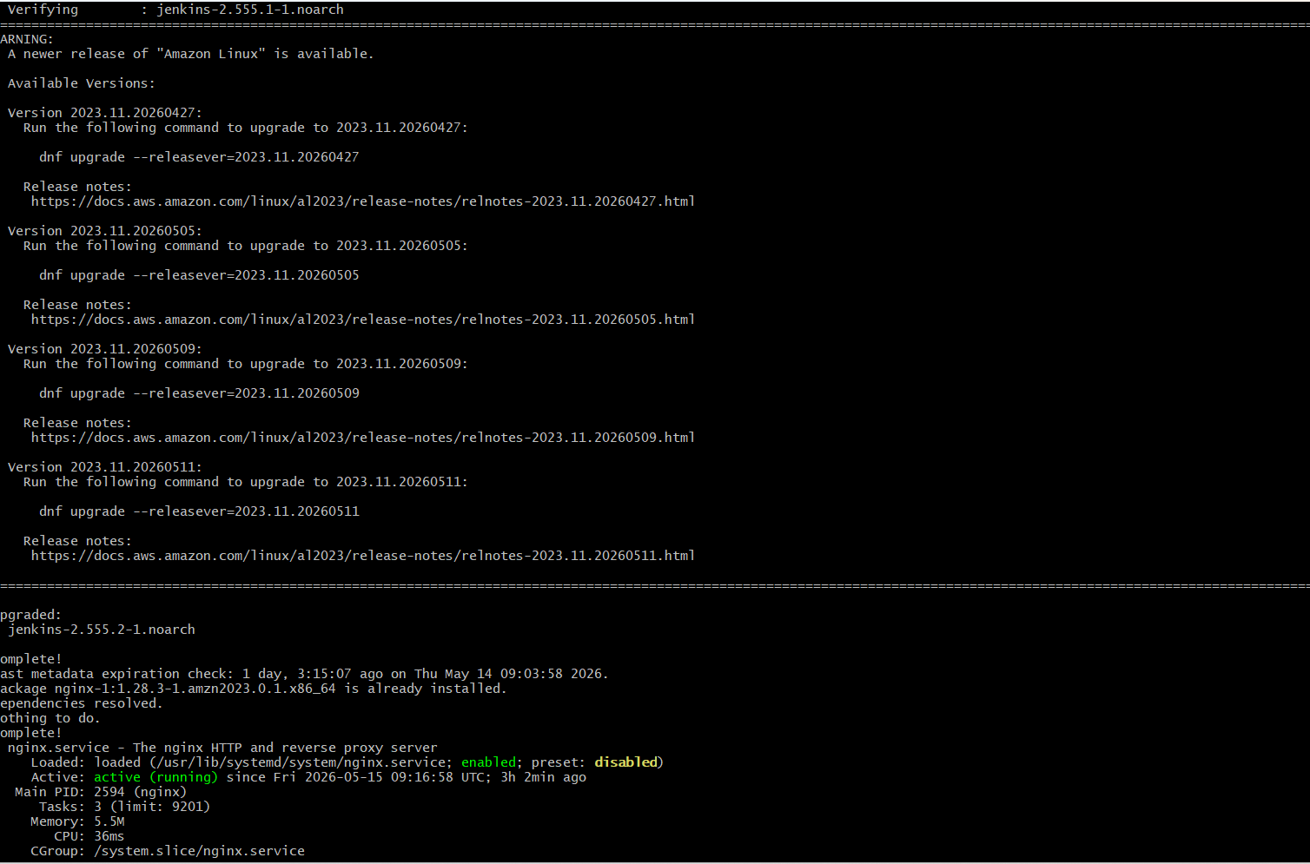
Nginx working on browser
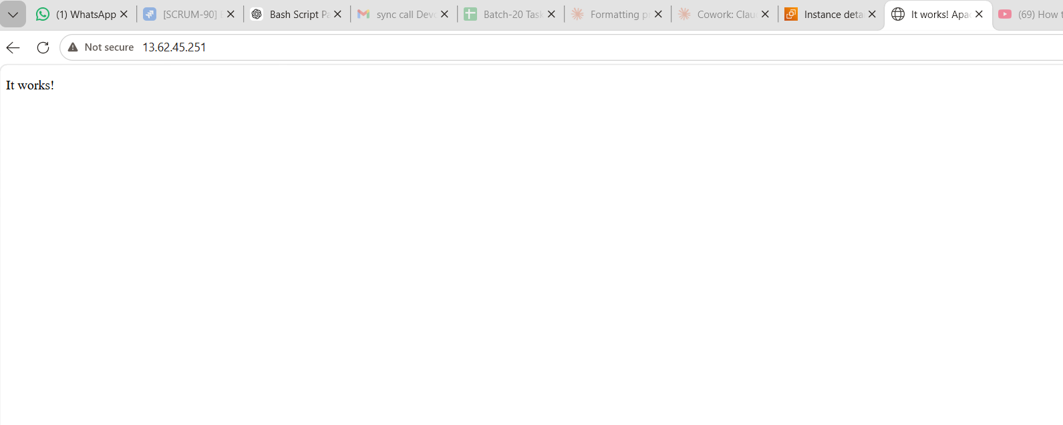
- Create a bash script to install Apache Tomcat on an EC2 server.
#!/bin/bash
USER=tomcat

echo "🔹 Updating system..."
sudo yum update -y

echo "🔹 Installing Java..."
sudo yum install java-17-amazon
corretto -y

echo "🔹 Creating Tomcat user..."
sudo useradd -m -U -d $TOMCAT_DIR -s /bin/false $USER || true

echo "🔹 Downloading Tomcat..."
cd /tmp
wget
https://archive.apache.org/dist/tomcat/tomcat-10/v$TOMCAT_VERSION/bin/apache-tomcat-$TOMCAT_VERSION.tar.gz

echo "🔹 Creating installation directory..."
sudo mkdir -p $TOMCAT_DIR

echo "🔹 Extracting Tomcat..."
sudo tar -xvzf apache-tomcat-$TOMCAT_VERSION.tar.gz -C $TOMCAT_DIR --strip-components=1

echo "🔹 Setting permissions..."
sudo chown -R $USER:$USER $TOMCAT_DIR
sudo chmod +x $TOMCAT_DIR/bin/*.sh

echo "🔹 Creating systemd service..."

sudo bash -c 'cat > /etc/systemd/system/tomcat.service <<EOF
[Unit]
Description=Apache Tomcat Server
After=network.target

[Service]
Type=forking
User=tomcat
Group=tomcat

Environment=JAVA_HOME=/usr/lib/jvm/java-17-amazon-corretto
Environment=CATALINA_HOME=/opt/tomcat
Environment=CATALINA_BASE=/opt/tomcat

ExecStart=/opt/tomcat/bin/startup.sh
ExecStop=/opt/tomcat/bin/shutdown.sh

Restart=always

[Install]
WantedBy=multi-user.target
EOF'

echo "🔹 Starting Tomcat..."
sudo systemctl daemon-reload
sudo systemctl start tomcat
sudo systemctl enable tomcat

echo "✅ Tomcat installed successfully!"
- echo "👉 Open: http://<EC2-PUBLIC-IP>:8080"

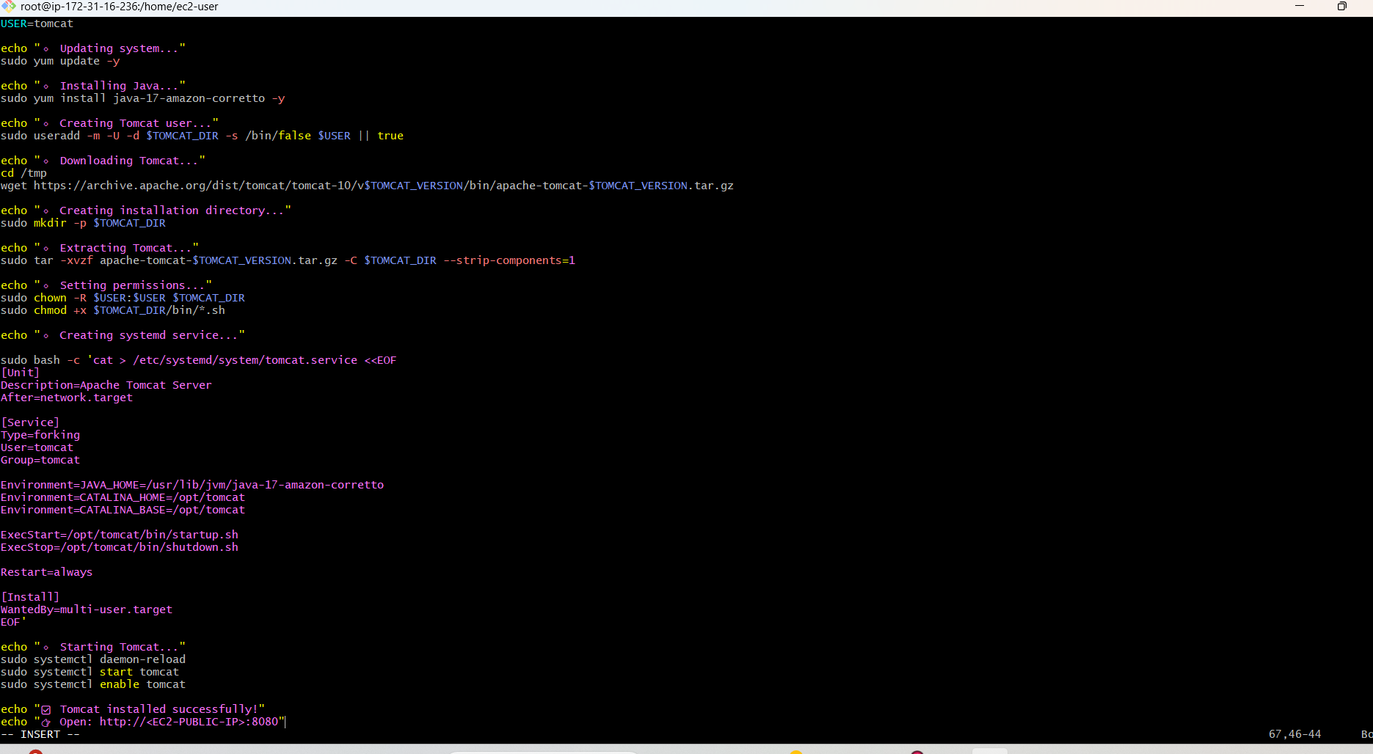
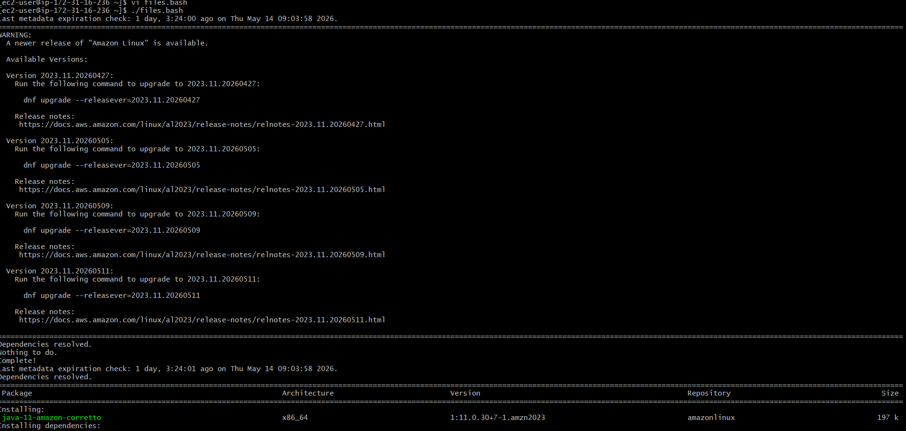
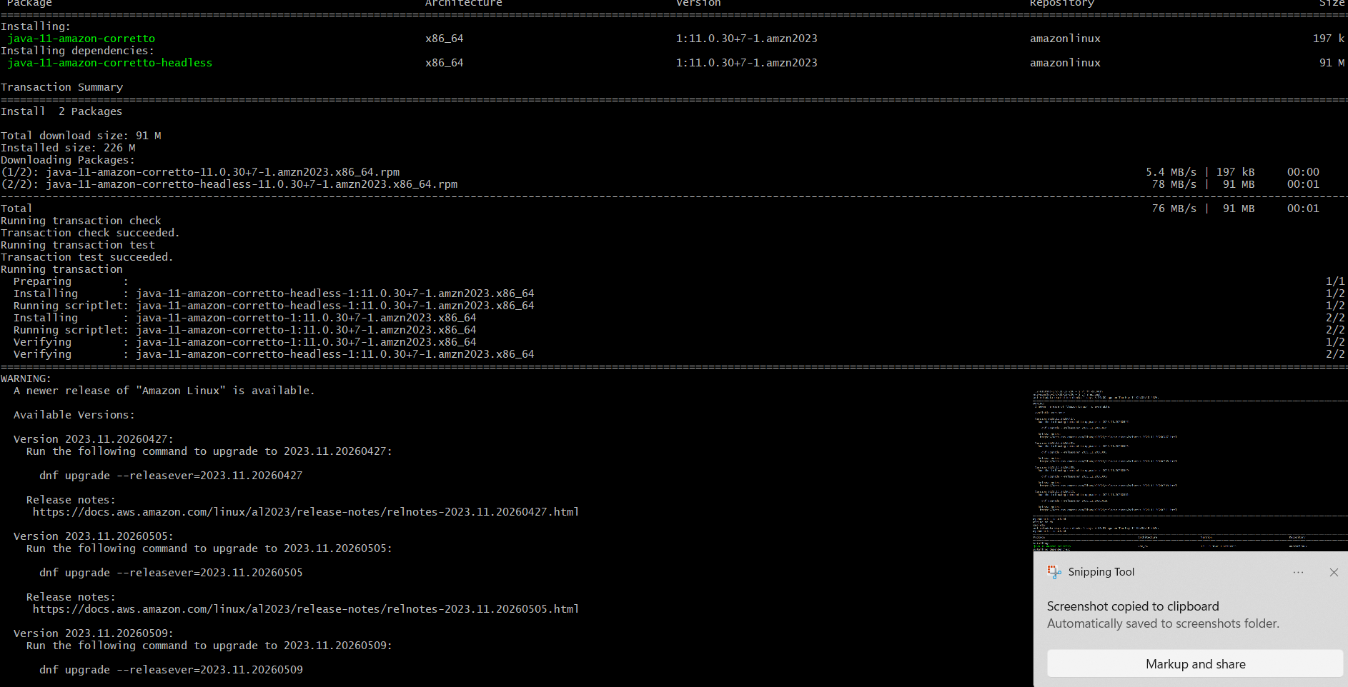
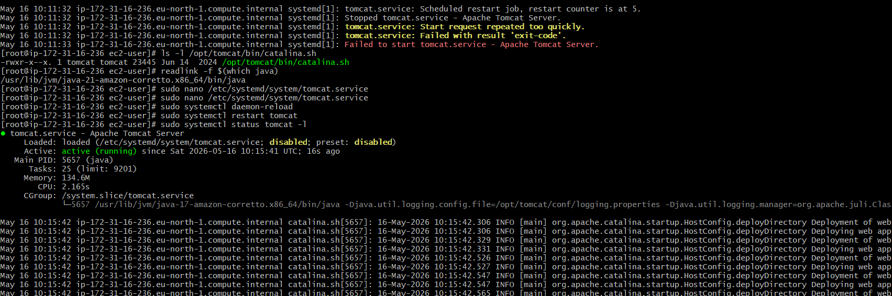
Apache Tomcat httpd now working on web page
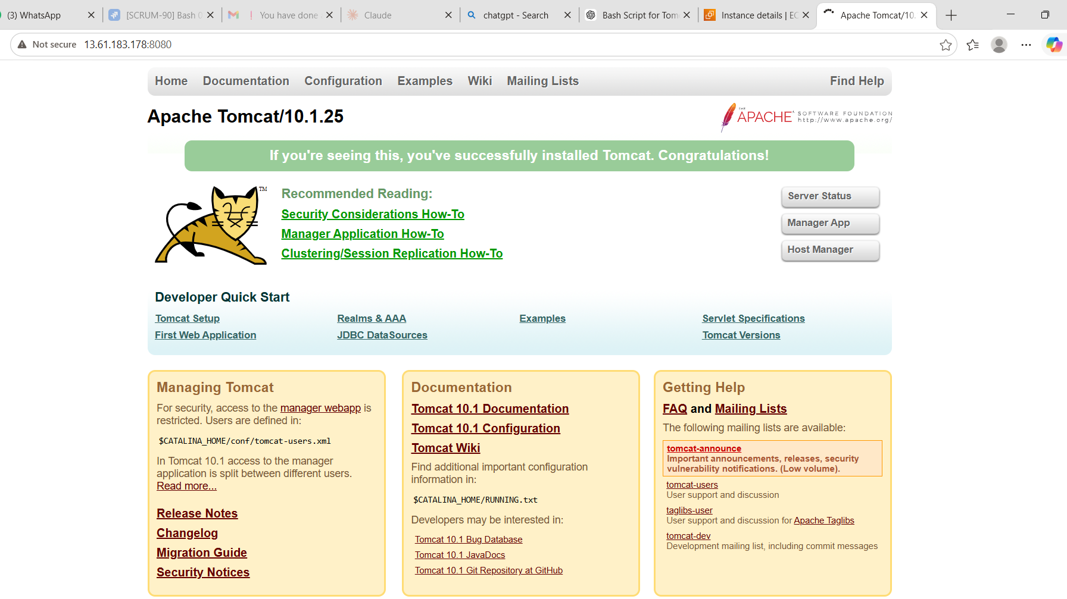

6.Create a bash script to check if the
Nginx service is running, if not running then script should start the service.
#!/bin/bash

status=$(systemctl is-active nginx)

if [ "$status" = "active" ]; then
echo "Nginx is already running"
else
echo "Nginx is not running. Starting Nginx..."
sudo systemctl start nginx
echo "Nginx started successfully"
fi
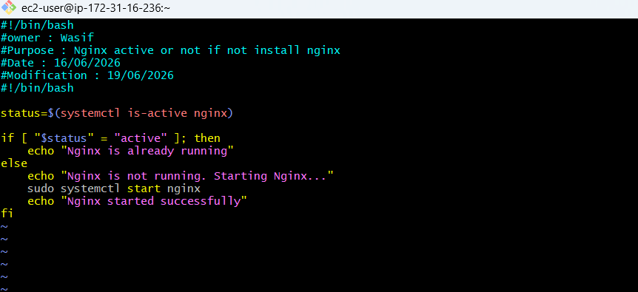
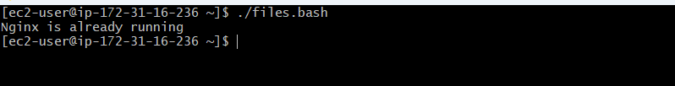
- Create a bash script for a calculator.
#!/bin/bash

echo "Simple Bash Calculator"
echo "Enter first number:"
read a

echo "Enter second number:"
read b

echo "Choose operation:"
echo "1 = Addition"
echo "2 = Subtraction"
echo "3 = Multiplication"
echo "4 = Division"

read choice

case $choice in
1)
echo "Result: $((a + b))"
;;
2)
echo "Result: $((a - b))"
;;
3)
echo "Result: $((a * b))"
;;
4)
if [ $b -ne 0 ]; then
echo "Result: $((a / b))"
else
echo "Cannot divide by zero"
fi
;;
*)
echo "Invalid choice"
;;
esac
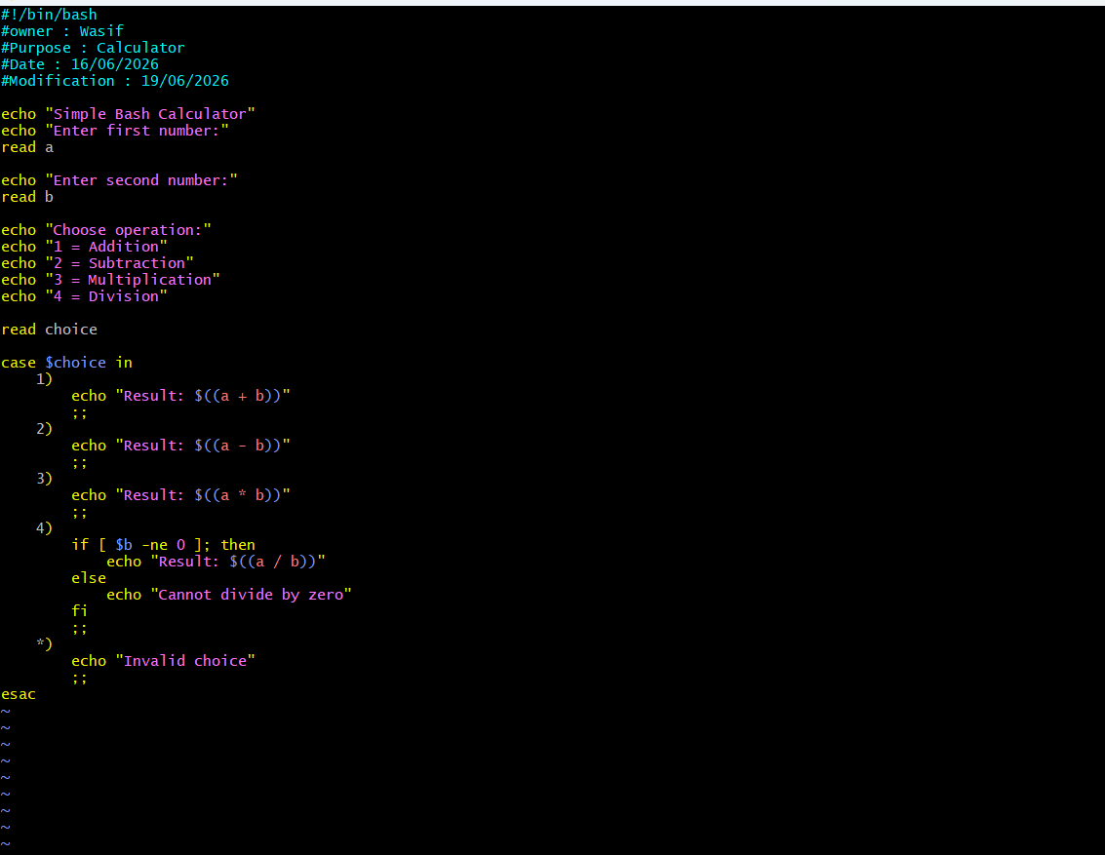
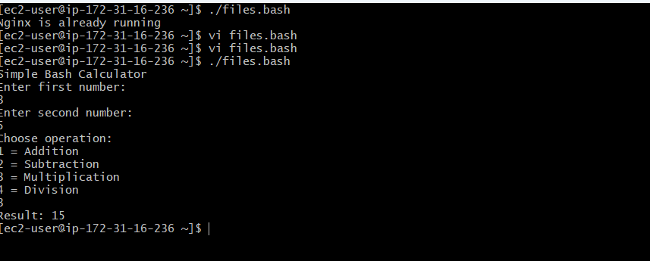
- Create a bash script to check if a directory exists, if not then create a directory.
#!/bin/bash

dir="/home/ec2-user/testdir"

if [ -d "$dir" ]; then
echo "Directory already exists"
else
mkdir -p "$dir"
echo "Directory created successfully"
fi
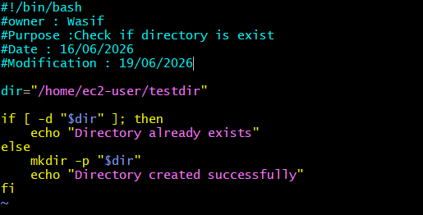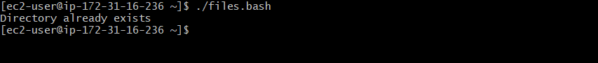
- Create a bash script to delete the last 3 lines of a file.
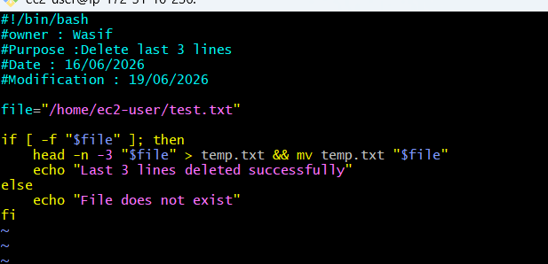
Created file and then deleted
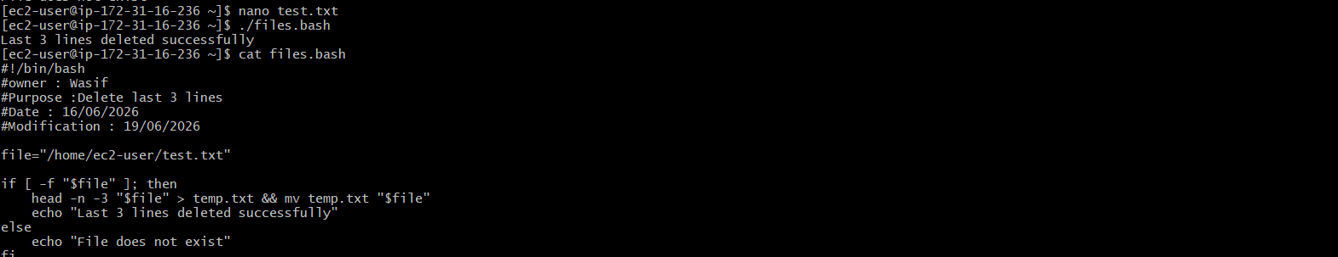
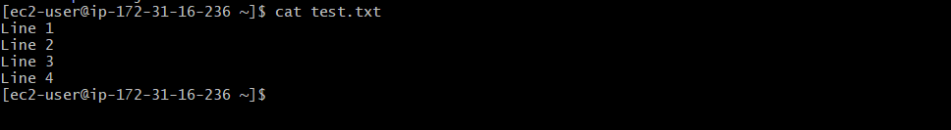
- Bash script to monitor cpu and if it is more than 80% then send email notification.
#!/bin/bash

threshold=80

cpu_usage=$(top -bn1 | grep "Cpu(s)" | awk '{print $2 + $4}')

cpu_int=${cpu_usage%.*}

if [ "$cpu_int" -gt "$threshold" ]; then
echo "CPU usage is high: ${cpu_usage}%" | mail -s "CPU Alert" admin@example.com
echo "Alert sent: CPU usage is ${cpu_usage}%"
else
echo "CPU usage is normal: ${cpu_usage}%"
fi
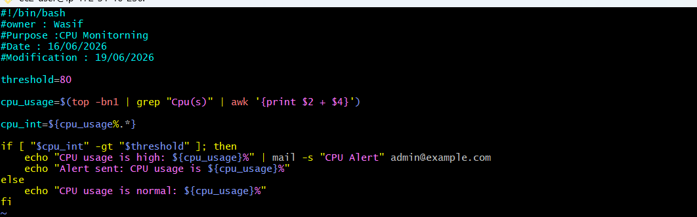
- Bash script to monitor disk space and if it is more than 80% then send email notification.
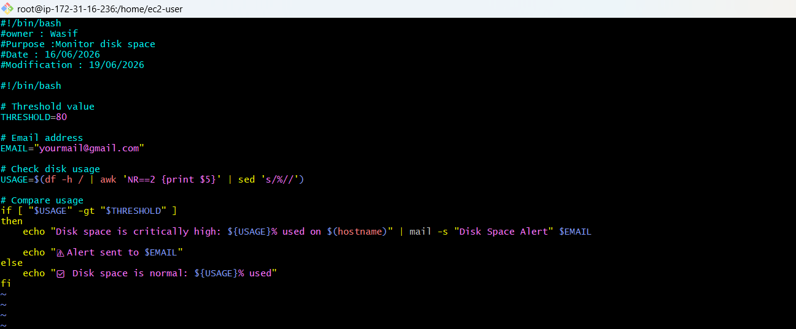
- Bash script to monitor memory and if it is more than 80% then send email notification.
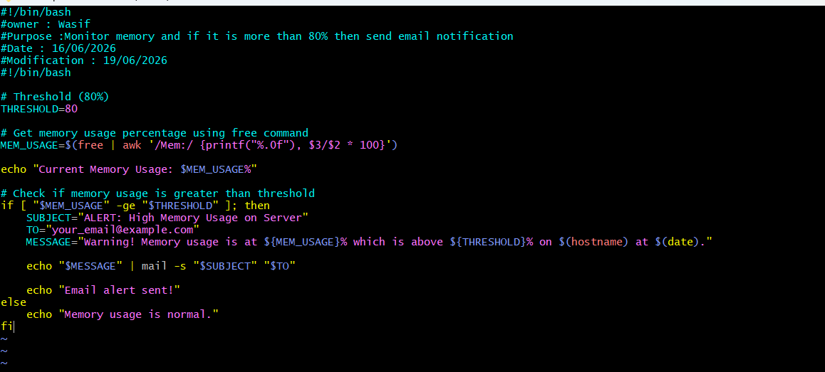
Exercise: Crontab Entries
- April 5th Midnight
0 0 5 4 * /home/ec2-user/test.sh
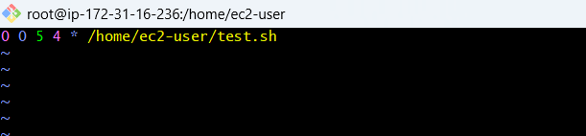
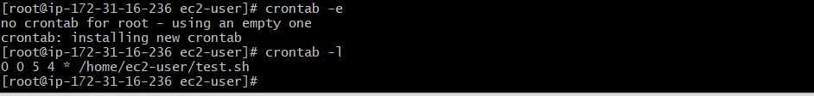
- 5th of Every November, January, June if it is a Thursday
Command
0 0 5 1,6,11 4 /home/ec2-user/test.sh
Thur – 4
Jan,jun,Nov = 1,6,11
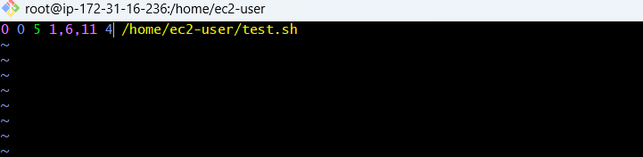
- At05 and 27th minutesof9, 10, 11hours every day
Command
5,27 9-11 * * * /home/ec2-user/job.sh
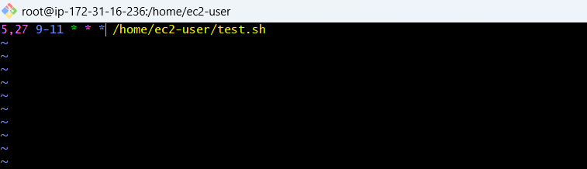
- 34 minutesof9th houron15th August
Command :
34 9 15 8 * /home/ec2-user/job.sh
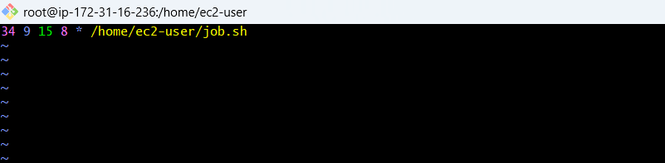
- Every midnight
Command:
0 0 * * * /home/ec2-user/job.sh
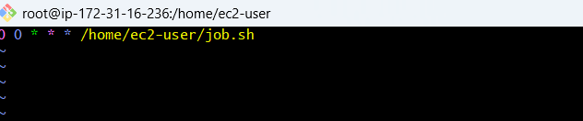
- Every Weekend (Saturday night 11:59 PM)
Command: 59 23 * * 6 /home/ec2-user/job.sh
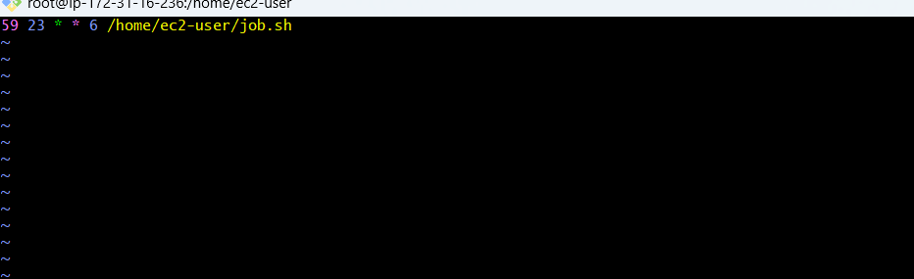
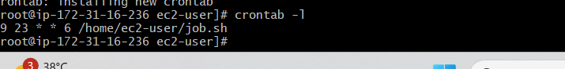
- After every reboot
Cron provides a special keyword:@reboot
@reboot

Run once after system startup
Command: @reboot /home/ec2-user/job.sh
